**Name:** Soham Bhoir

**Roll No.:** 16010420117

**Batch:** B2

**Mail Id:** [soham.bhoir@somaiya.edu](mailto:soham.bhoir@somaiya.edu)

EEFM IA-1

1) **Tata Consultancy Services** (Sector: Technology (IT))

**Logo:**

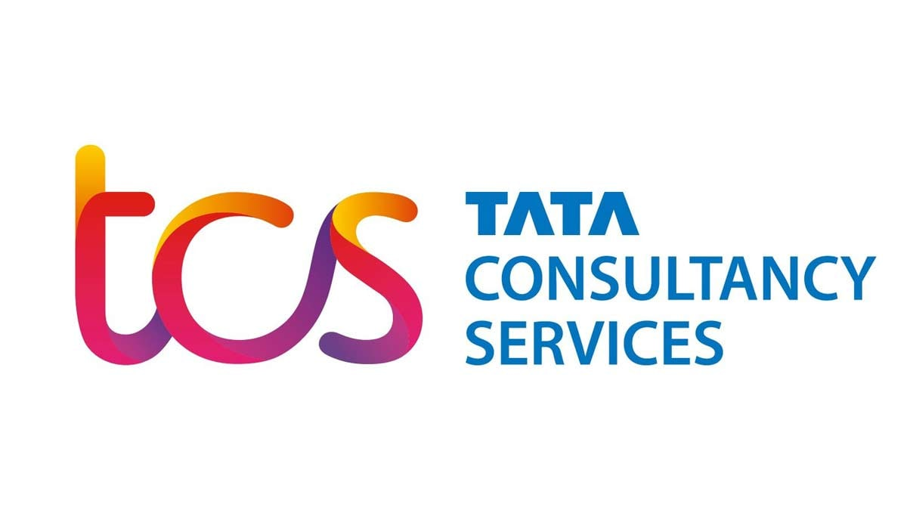

**Address of TCS**:

TCS House, Raveline Street, Fort, Mumbai 400001, Maharashtra, India

**Introduction:**

1968 saw the establishment of Tata Consulting Services Ltd. by a division of Tata Sons Limited. The renowned Indian information technology (IT) services, consulting, and business solutions firm with its headquarters in Mumbai is called Tata Consultancy Services Limited (TCS). TCS has operations in 46 different nations. TCS is the largest India-based IT services corporation and the largest Indian company by market capitalization. One of the "Big 4" most valued IT services brands globally, TCS is today. TCS is the highest-ranked provider of IT services and the top Indian firm in 2013, according to Forbes' list of the world's most innovative companies. Effective Change Management, according to TCS, is a process where art, science, and craft come together.

**About:**

**Goals of TCS:**

**INSPIRE ENGAGEMENT** and connect employees to the Global Goals,**TRANSFORM COLLECTIVE ACTION** at a local and regional level,**MEASURE IMPACT** and outcomes of employee volunteer programs on the SDGs, and **IGNITE INNOVATION** in the design of employee volunteer programs.

TCS’s purpose is to **connect people to opportunities in the digital economy** and that mission is central to the way it operate as a business. Through innovation, partnership, and collective knowledge, TCS believes it can lead positive change for all stakeholders.

TCS is committed to the following four Core Values:

* Reliable- Do what is needed.
* Innovative– Improve everything.
* Caring– Love your neighbor.
* Humble– Put others first.

**Financial Statement of TCS:**

**SWOT Analysis of TCS:**

**SWOT Analysis of TCS:**

**Strengths of TCS**

* Extensive Global Reach.
* Major number of Customers from various sectors.
* Strong reputed Brand Image in the market.
* Robust Service Portfolio.
* Empowered and encouraged employees.
* Excellent returns on capital.

**Weaknesses of TCS**

* Performance of Diligenta deteriorated.
* Legal Squabbles.
* The product segment is not relatively.

**Opportunities for TCS**

* Emerging Interest in Cloud Computing.
* M2M Solutions.
* Transformation of the Digital Universe.
* Solutions for mobility.

**Threats to TCS**

* Competition is fierce.
* A high rate of attrition.
* The Constraints on Immigration.
* Large multinational corporations**.**

**Future Marketing strategy and promotional plan of Company:**

Customer-centricity is at the heart of TCS’ approach. They collaborate closely with customers and design customized technology solutions based on our in-depth understanding of their industry. These solutions cater to their customers’ specific requirements, establishing them as trusted partners. Consistent revenue growth, a high amount of repeat business, good client metrics, long-term customer relationships, best-in-class margins, and a gradually rising market share demonstrate the success of this strategy.

## **Sponsorships**

### 1. TCS New York City Marathon

TCS has been the title sponsor of the world’s largest marathon, undoubtedly, since 2014. The TCS NYC Marathon is one of TCS’s numerous global running events (others include the Amsterdam Marathon and the TCS Lidingöloppet), and it exemplifies the company’s dedication to giving back to the communities in which it operates.

### 2. Invictus Games

Since its start in London in 2014, Jaguar Land Rover has been a Presenting Partner of The Invictus Games. The Games are supported financially by JLR. The Games’ enormous impact on recovery continues to inspire and motivate sick, wounded, and ill Servicemen and women.

### 3. Tata Crucible

The Tata Crucible, India’s largest business quiz, is a knowledge endeavour that brings together India’s brightest minds to compete in a fast-paced quiz that promotes lateral thinking. The yearly, nationwide tournament, which began in 2004, is split into two tracks for corporates and campus students. In addition to Singapore and Dubai, the campus edition is hosted in Singapore and Dubai.

### 4. Live Tata Literature!

Anil Dharker, the founder and CEO of the Tata group, is the event’s title sponsor. The festival, which takes place every November, is known for bringing together the biggest personalities in the literary world as well as heated debates on economics, politics, and social concerns.

### 5. First Book

Tata For more than a decade, North America and First Book have collaborated to improve the lives of children by ensuring that all children have equitable access to quality education and assisting those who are in need. Tata and First Book help youngsters learn to read by giving them books and other learning materials. Over 500,000 books have been delivered since 2008, according to the organization.

# **Marketing campaigns of TCS**

### 1. #TCSPartOfYourStory

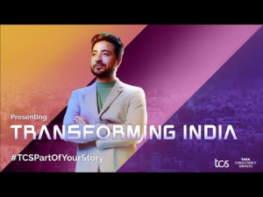

TCS launched a corporate brand campaign dubbed #TCSPartOfYourStory to highlight the company’s role in India’s digital journey and how it paved the way for India’s people to experience innovation and progressive development.

The #TCSPartOfYourStory campaign highlights some of the most compelling stories of Digital India, as well as TCS’ pivotal role in constructing the country’s digital backbone, which spans financial services, government services, health care and pharmaceuticals, logistics and supply chain networks, science and technology, consumer business, and more.

It allowed people to benefit from the technological boom that has revolutionized the country and its inhabitants. This ad provides an up-close and personal look at powerful TCS tales that have an impact on everyone’s lives.

### 2. The New Tagline of TCS

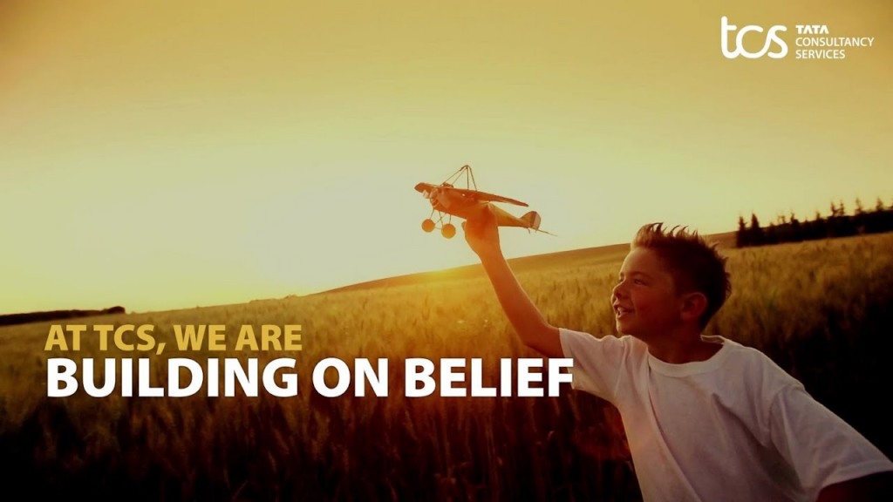

After 15 years, Tata Consultancy Services (TCS) has revamped to appeal to millennials. The company’s new tagline, which replaces “Experience Certainty,” is “Building on Belief.”

‘Building on Belief,’ according to the business’s Chief Marketing Officer (CMO), does not imply that the corporation is abandoning its promise of assurance to its customers. The new tagline, according to Rajashree, is designed to appeal to millennials, not just about where TCS is now, but also about where the company wants to be in the next decade. She stated that it is centered on bringing the voice of the “young TCS” to the forefront.

# **Digital Presence of TCS**

The TCS has accounts on all of the major social networking sites. They focus on their rich history and showcase their developments as well as their future intentions through their accounts.

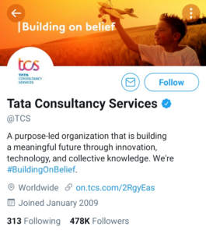      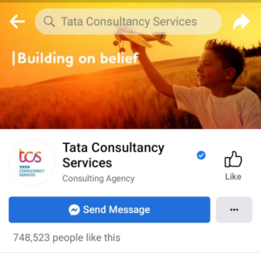      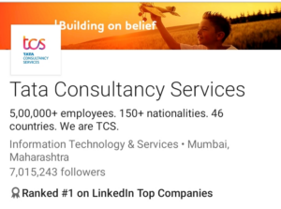

* **Instagram:**On Instagram, TCS (Tata Consultancy Service) has a following of 284,000 people. They use Instagram stories and posts to announce new initiatives and items.
* **Twitter:** On Twitter, TCS (Tata Consultancy Services) has 478,000 followers. The inventive use of hashtags and the organization of rewarding competitions are the reasons for such a large following on Twitter.
* **Linkedin:**TCS has a LinkedIn following of 7,015,243 people. The content on LinkedIn is primarily inspired by TCS’s other social media platforms. The increasing reach is due to the TCS’s brand value and awareness, which encourages young people to seek employment here.
* **Facebook:**Around 748,523 individuals like the Tata Group’s page on Facebook. The stuff is very similar to what they post on Instagram.

**Conclusion:**

TCS has seen excellent revenue growth as demand for its core transformation services develops and through landing transactions worth more than USD 6.8 billion in the fourth quarter of 2020. Tata Consultancy Services (TCS) is the third most valuable IT services brand in the world, behind Accenture and IBM, and holds a slot in the top ten.TCS has dominated not only the Indian industry but also the worldwide market, thanks to its diverse workforce base, cutting-edge technology, and innovative business models. TCS is hoping for even better results in the coming year.

TCS is unquestionably the best in its industry. It has numerous and noteworthy strengths. For a company like TCS with such a great brand image, brand backing, market command, portfolio, reach, and so on, it needs just a little more work to address its weaknesses and be more alert to threats. If TCS pays more attention to its strengths and expands as well as adjusts even further for new opportunities, TCS will be able to keep its crown.